Wholesale Parts E-Commerce Platform
Architecture Overview & Implementation Plan
Project Timeline: 4 Weeks
Operational Cost: ~$25-30/month
Scale: 15,000 Products | 4,000+ Users

Table of Contents
Table of Contents 1
System Architecture Diagram 1
System Architecture Overview 1
High-Level Summary 1
Architecture Layers 1
1. User Layer 1
2. Frontend Layer (Next.js 15 on Vercel - Free Tier) 1
3. Backend Layer (Supabase - Free Tier) 1
4. Integration Layer (n8n Cloud - $20/month) 1
5. External Services Layer 1
Key Data Flows 1
Phase-Wise Implementation Plan 1
PHASE 1: Foundation & Infrastructure (Week 1-2 | Days 1-14) 1
PHASE 2: Core Features (Week 3 | Days 15-21) 1
PHASE 3: Production Readiness (Week 4 | Days 22-28) 1
Total Cost Breakdown 1
Final Checklist Before Launch 1

System Architecture Diagram
The following diagram illustrates the complete system architecture, showing all components, data flows, and integrations across the 5-tier design:

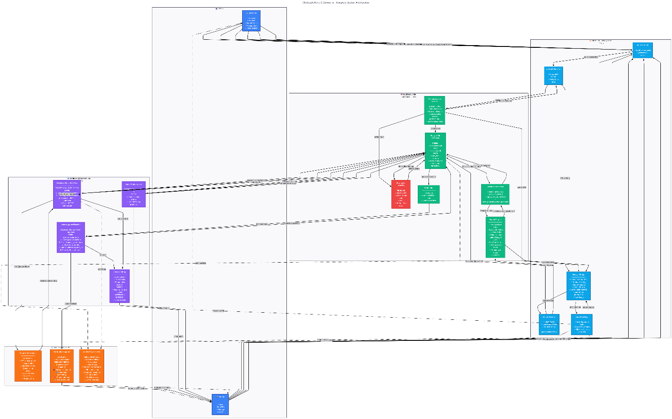

System Architecture Overview

High-Level Summary
This is a modern, serverless e-commerce platform designed for wholesale mechanical parts distribution. The architecture follows a 4-tier design optimized for scalability, security, and cost-efficiency (~$25/month operational cost).

Architecture Layers

1. User Layer
- Customer Users: Browse 15,000+ products, search inventory, manage shopping carts, place inquiry orders
- Admin Users: Access analytics dashboard, manage orders, update statuses, monitor system health

2. Frontend Layer (Next.js 15 on Vercel - Free Tier)
Technology: Next.js 15 on Vercel (Free Tier)
Components:
- Route Groups: Organized routing with authentication middleware
  - (public) - Public pages (no auth required)
  - (customer) - Protected customer pages
  - (admin) - Admin-only pages with role verification

- Next.js 15 App: Modern React framework
  - Server Components: Product catalog, search results, order history (reduce client JS)
  - Client Components: Interactive elements (search bar with debounce, cart badge, forms)
  - Server Actions: Type-safe mutations (addToCart, createOrder, updateOrderStatus)
  - Middleware: JWT authentication, role verification, route protection

- Vercel Hosting:
  - Automatic deployments on git push
  - Global Edge CDN for fast delivery
  - Built-in SSL certificates
  - Preview deployments for testing
  - Real-time analytics

3. Backend Layer (Supabase - Free Tier)
Technology: Supabase (PostgreSQL + Auth)
Core Components:
Authentication Service (Security Critical):
- Email/Password signup flow
- Automatic profile creation via database triggers
- JWT token generation and validation
- Session management (7-day expiry)

PostgreSQL Database:
- products table: 15K mechanical parts with full-text search vectors
- profiles table: User data (company, phone, role)
- cart_items table: Temporary shopping cart storage
- orders table: Order inquiries with JSON snapshots
- daily_analytics table: Pre-aggregated metrics
- sync_logs table: Sync audit trail

Row Level Security (RLS):
- Products: Public read, admin-only write
- Cart: Users only see their own items
- Orders: Users see own orders, admins see all
- Analytics: Admin-only access

Search Engine (3-Tier Architecture):
- Tier 1: Exact SKU match (B-tree index, <10ms)
- Tier 2: Full-text search (GIN tsvector index, <300ms)
- Tier 3: Fuzzy matching (ILIKE on category/brand, <500ms)
- Ranking: Combines relevance score × stock availability bonus

Database Functions:
- search_products(): Advanced 3-tier search algorithm
- get_cart_total(): Calculate cart totals
- aggregate_analytics(): Daily metrics computation
- Auto-generate order numbers (ORD-2024-00001)

Webhooks:
- Trigger on orders.INSERT event
- POST order data to n8n workflow
- Asynchronous processing for WhatsApp notifications

4. Integration Layer (n8n Cloud - $20/month)
Database Sync Workflow:
- Trigger: Cron schedule (every 30 minutes: */30 * * * *)
- Fetch last sync timestamp from logs
- GET updated products from Client PHP API
- Transform PHP data format → Supabase schema
- Batch process (100 products per batch)
- UPSERT to Supabase (insert new, update existing)
- Log results to sync_logs table
- Send alert email on failures

WhatsApp Notification Workflow:
- Trigger: Webhook from Supabase on new order
- Parse order data from webhook payload
- Fetch additional product details if needed
- Format WhatsApp message template
- POST to Twilio WhatsApp API
- Update order.whatsapp_sent_at timestamp
- Email fallback on failure

Daily Analytics Job:
- Trigger: Cron (daily at 1 AM: 0 1 * * *)
- Count today's orders
- Calculate top 5 products (last 7 days)
- Aggregate unique user stats
- Insert to daily_analytics table
- Email summary report to admin

5. External Services Layer
Client PHP Database:
- Existing legacy system (read-only access)
- 15,000+ products with stock status
- REST API endpoints: /api/products
- Supports incremental sync with ?updated_since={timestamp}

Twilio WhatsApp API:
- Official WhatsApp Business API
- POST to /Messages endpoint
- Message format: Order details with emojis, customer info, direct link
- Cost: $0.005 per message (~$5/month for 1000 orders)

Monitoring Services:
- Vercel Analytics: Response times, error rates, Web Vitals
- Supabase Dashboard: DB connections, query performance
- UptimeRobot: Health checks every 5 minutes (free)

Key Data Flows
Flow 1: Product Search
Customer → Search Bar (debounce 300ms) → Next.js Server Action → Search Engine (3-tier algorithm) → PostgreSQL (tsvector query) → Ranked Results → Customer (< 500ms total)
Flow 2: Order Creation
Customer → Cart → Checkout Form → Next.js Server Action → PostgreSQL (create order + clear cart) → Webhook Trigger → n8n Workflow → Twilio WhatsApp → Admin Notification
Flow 3: Database Synchronization
n8n Cron (every 30 min) → Client PHP API (incremental fetch) → Data Transformation → Batch Processing → Supabase UPSERT → Sync Logs → Email Alert (on errors)
Flow 4: Admin Dashboard
Admin Login → Auth Verification → Role Check → Parallel Data Fetch (4 queries) → React Query Cache → Dashboard Render with Real-time Metrics

Phase-Wise Implementation Plan
This 4-week development roadmap breaks down the entire project into manageable sprints with clear deliverables and success criteria.

PHASE 1: Foundation & Infrastructure (Week 1-2 | Days 1-14)
Objective: Build the technical foundation - database, authentication, and basic product browsing
Sprint 1.1: Database Setup (Days 1-2)
Owner: Backend Developer | Priority: Critical
Tasks:
- ☑ Create Supabase project and configure settings
- ☑ Design complete database schema (7 tables)
- ☑ Create tables with proper relationships and constraints
- ☑ Add performance indexes (B-tree, GIN for full-text search)
- ☑ Implement Row Level Security (RLS) policies for all tables
- ☑ Create database functions (search_products, auto-triggers)
- ☑ Seed database with 100+ sample products for testing
- ☑ Run performance tests on search queries
Deliverables:
- Fully configured Supabase project
- Database schema documentation
- Sample data loaded and queryable
- RLS policies tested and verified

Sprint 1.2: Authentication System (Days 3-4)
Owner: Backend Developer | Priority: Critical
Tasks:
- ☑ Configure Supabase Auth settings
- ☑ Build login page UI with form validation
- ☑ Build signup page UI with company information fields
- ☑ Create database trigger for automatic profile creation
- ☑ Implement auth hooks in Next.js
- ☑ Set up middleware for route protection
- ☑ Test complete auth flow: signup → email verification → login
- ☑ Implement role-based access control (customer vs admin)
Sprint 1.3: Next.js Application Setup (Days 3-4)
Owner: Frontend Developer | Priority: Critical
Tasks (Parallel with Sprint 1.2):
- ☑ Initialize Next.js 15 project with TypeScript
- ☑ Install dependencies: Supabase client, UI libraries, Tailwind CSS
- ☑ Configure TypeScript strict mode and ESLint rules
- ☑ Set up folder structure with route groups
- ☑ Create layout components (Header, Footer, Navigation)
- ☑ Build reusable UI components (Button, Card, Modal, Toast)
- ☑ Configure Tailwind CSS with custom design tokens
- ☑ Set up environment variables (.env.local template)

Phase 1 Success Criteria:
- ☑ Database schema complete and tested
- ☑ Users can sign up and log in
- ☑ Product catalog displays 1000+ products
- ☑ Search returns results in < 500ms
- ☑ Manual sync successfully imports products
- ☑ All protected routes require authentication
- ☑ Mobile responsive (tested on 3 devices)

PHASE 2: Core Features (Week 3 | Days 15-21)
Objective: Implement shopping cart, order inquiry system, WhatsApp notifications, and admin dashboard
Sprint 2.1: Shopping Cart System (Days 15-16)
Owner: Full-Stack Developer | Priority: Critical
- ☑ Create cart_items table with unique constraint
- ☑ Build cart page UI showing items, quantities, totals
- ☑ Create addToCart() server action with optimistic updates
- ☑ Implement updateQuantity() with +/- controls
- ☑ Add removeFromCart() functionality
- ☑ Build cart badge in header (shows item count)
- ☑ Handle edge cases: out-of-stock items, duplicate adds
- ☑ Test cart persistence across sessions
Phase 2 Success Criteria:
- ☑ Users can add products to cart
- ☑ Cart persists across sessions and devices
- ☑ Orders create successfully with snapshots
- ☑ WhatsApp notifications delivered < 30 seconds
- ☑ Admin dashboard shows accurate metrics
- ☑ Admin can update order status
- ☑ All features work on mobile devices

PHASE 3: Production Readiness (Week 4 | Days 22-28)
Objective: Automate workflows, harden security, add monitoring, and deploy to production
Security Hardening Checklist:
Security Item | Status
All RLS policies active and tested | ☐
Password minimum 6 characters | ☐
Session expires after 7 days | ☐
HTTPS enforced in production | ☐
Security headers configured | ☐
No API keys in client-side code | ☐
Input validation on all forms | ☐
Rate limiting active | ☐

Total Cost Breakdown
Operational Costs (Monthly):
Service | Tier | Monthly Cost | Annual Cost
Vercel Hosting | Hobby (Free) | $0 | $0
Supabase | Free Tier | $0 | $0
n8n Cloud | Starter | $20 | $240
Twilio WhatsApp | Pay-as-you-go | ~$5 | ~$60
TOTAL |  | ~$26/month | ~$312/year
Scaling Projections:
- At 10,000 users: $51/month (upgrade Supabase to Pro $25)
- At 50,000 users: $95/month (upgrade Vercel Pro $20, n8n Pro $50)

Final Checklist Before Launch
Technical:
- ☐ All features working end-to-end
- ☐ Security audit passed
- ☐ Performance targets met (Lighthouse > 90)
- ☐ Error handling comprehensive
- ☐ Monitoring and alerts configured
- ☐ Database backups enabled
- ☐ SSL certificates active
Documentation:
- ☐ User guides complete
- ☐ Admin documentation ready
- ☐ Technical documentation finalized
- ☐ API documentation published
- ☐ Troubleshooting guide available
Team:
- ☐ Admin team trained
- ☐ Support process defined
- ☐ On-call rotation scheduled
- ☐ Post-launch roadmap agreed

